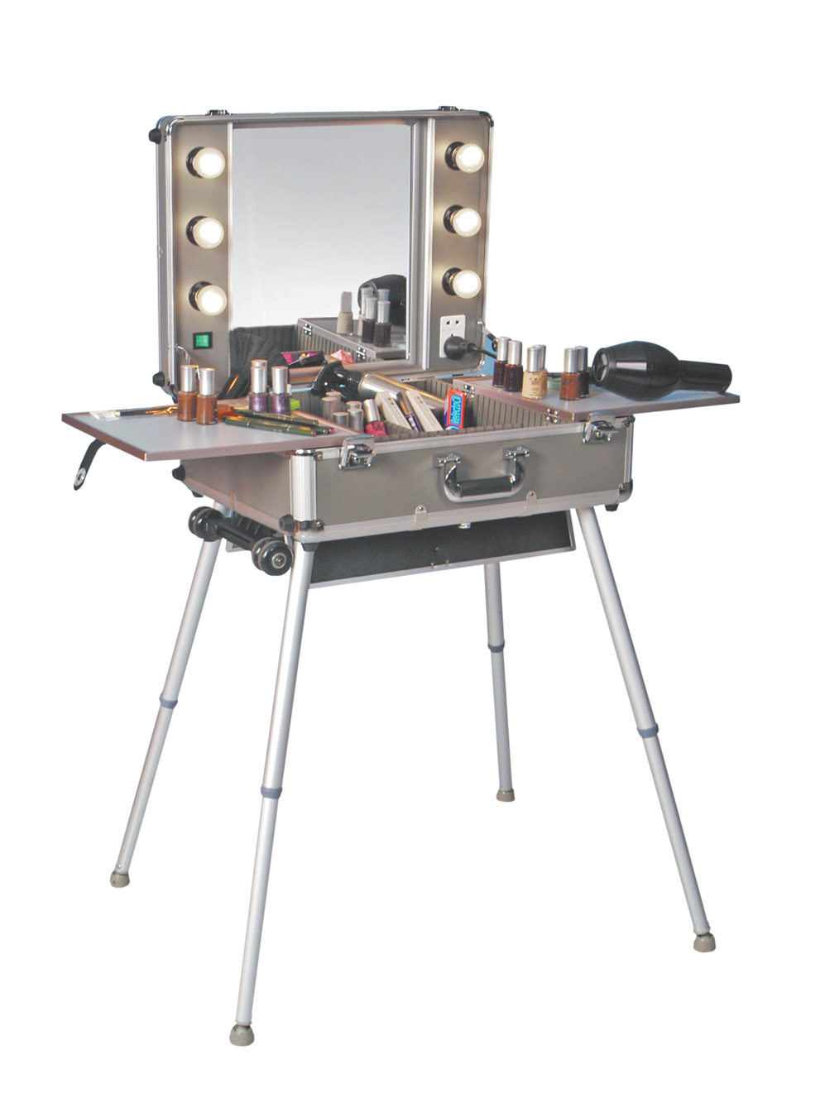
(Music; Peggy Lee - Goody Goody)
(Music; Peggy Lee - Goody Goody)


(Music; Peggy Lee - Goody Goody)
(Music; Peggy Lee - Goody Goody)


The new formula eliminates the need for other products such as sunscreen and concealer, saving you time and money. Aqua 16-hour Foundation SPF 30 provides unbelievable coverage and lasts all day.

Times change. Quality doesn’t have to. Aqua 16-hour Foundation SPF 30 is the newest product from Klein Kosmetics. It provides the same classic look you expect, with just one product.


Get your classic look tonight! Sold at your local drugstore.

(Music; Frank Sinatra – The Way You Look Tonight)

